Table of Contents
Consumer Product Safety Analysis 3
1. Business Understanding 3
1.1 Background 3
1.1.1 Organizational/Context Description 3
1.1.2 Domain and Context Assessment 3
1.1.3 Problem Situation 5
1.1.4 Data Science Justification 5
1.1.5 Stakeholder Identification 6
1.2 Project Objectives and Success Criteria 6
1.2.1 Primary Objective 6
1.2.2 Secondary Objectives 7
1.2.3 Quantitative Success Criteria 7
1.2.4 Qualitative Success Criteria 8
1.2.5 Impact Assessment 8
1.2.6 Timeline and Milestones 9
1.3 Assessment of Responsibility 9
1.3.1 Legal and Regulatory Considerations 9
1.3.2 Privacy and Data Protection 9
1.3.3 Bias and Fairness Concerns 11
1.3.5 Stakeholder Impact Analysis 12
1.3.5 Mitigation Strategies 12
1.4 Data Science Goals & Success Criteria 12
1.4.1 Technical Problem Framing 12
1.4.2 Data science Objectives 13
1.4.3 Technical Success Criteria 13
1.4.4 Analytical Approach Overview 13
1.4.5 Objective-Technical Mapping 14
1.4.6. Constraints and Assumptions 14
1.5 Project Plan 14
1.5.1 Phase specific planning 14
1.5.2 Timeline and milestones 16
1.5.3 Risk identification and contingencies 16
2 Data Understanding 18
2.1 Data Inventory 18
2.1.1 Primary Dataset Description 18
2.1.2 Additional Data Sources 19
2.1.3 Data Collection Methodology 19
2.2 Data Description 20
2.2.1 Comprehensive Data Dictionary 20
2.2.2 Dataset Structure and Description 27
2.2.3 Temporal Coverage and Granularity 28
2.2.4 Data Volume and Scale 29
2.2.5 Categorical Variable Encoding 29
2.3 Data Exploration Report 32
2.3.1 Univariate Analysis 32
2.3.2 Bivariate Relationships 39
2.3.3 Temporal Patterns and Trends 42
2.3.4 Organizational Level Segmentation 44
2.4 Data Quality Assessment 45
2.4.1 Completeness Analysis 45
2.4.2 Accuracy Assessment 47
2.4.3 Consistency Evaluation 48
2.4.4 Timelines and Currency 49
2.4.5 Relevance and Coverage 50
2.4.6 Data Quality and Impact Assessment 50

Consumer Product Safety Analysis

Business Understanding

1.1 Background

1.1.1 Organizational/Context Description
The Consumer Safety Research Institute (CSRI) is a specialized fictional nonprofit organization established in 2012 to perform independent research on consumer product safety and publish reports and insights that defines public disclosure, and aids in policy decisions. Consumer Safety Research Institute collects comprehensive injury data through systems like National electronic Injury surveillance system (NEISS) – which is a national database managed by U.S Consumer Product Safety Commission (CPSC) to track injuries treated in hospital emergency departments across the United States. While government agencies collect essential data, their raw reports are often cumbersome for the average consumer to understand and comprehend. CSRI fills this critical void, transforming complex datasets into clear public understanding of product risks.
The CSRI publishes an annual “Product Safety Spotlight” report that examines the emerging trends in product safety, identify areas of public attention and provides recommendations for consumers, manufacturers and policymakers. The report serves multiple stakeholders like the parent advocacy groups, policy researchers, product liability attorneys, insurance industry and regulatory agencies.

1.1.2 Domain and Context Assessment
The domain of consumer product safety is currently characterized by a significant disconnect between available data and public understanding. While the National Electronic Injury Surveillance System (NEISS) provides a robust foundation of comprehensive injury statistics, this raw data is technically complex and largely inaccessible to non-specialists. Consequently, the prevailing public discourse frequently relies on anecdotal evidence, high-profile media incidents, or biased manufacturer marketing rather than systematic, empirical analysis. This reliance on incomplete information leaves consumers, policymakers, and safety advocates without the evidence-based insights necessary for informed decision-making.
This information gap creates a critical challenge in an environment where stakeholders increasingly demand rigorous, independent verification to distinguish between isolated accidents and genuine systemic risks. There is a pressing market need for an authoritative intermediary capable of translating dense surveillance data into clear, actionable intelligence. However, few existing organizations possess the requisite combination of technical data expertise and institutional independence to conduct this analysis effectively.
The Consumer Safety Research Institute (CSRI) is strategically positioned to bridge this divide. By leveraging national injury surveillance data, CSRI transforms abstract statistics into evidence-based answers regarding product safety trends. The institute’s analytical work serves to ground public debate in fact, shifting the landscape from reactionary responses toward data-driven policy. In doing so, CSRI not only empowers consumers and regulators with clarity but also proactively identifies emerging safety threats, ensuring that manufacturers and governing bodies can address priority issues with precision and authority.

1.1.3 Problem Situation
While the government collects vast amounts of injury data, there is no effective mechanism to translate this raw information into accessible knowledge for the public.
Without independent analysis, safety decisions are made based on fear, marketing, or anecdotes rather than statistical reality, potentially leaving dangerous products on the market or causing unnecessary panic over minor issues.
There is an urgent requirement for an independent body capable of analyzing complex surveillance data and communicating objective, actionable findings to non-technical stakeholders.

1.1.4 Data Science Justification
Consumer Safety Research Institute (CSRI)has visibility of National Electronic Injury Survey Data (NEISS) data from 2005 through 2024.
The availability of NEISS transactional (at injury level) and demographic (Age/Sex//Race) data of 19 years represents a massive, high dimensional repository of public injury information. The volume and complexity of this data make any manual analysis cumbersome and time consuming.
We need to apply advanced machine learning and statistical analysis on this data to gather below insights from this massive dataset.
1.1.4.1 Trend Analysis and Seasonality
1.1.4.2 Identify Unstructured Narrative Data
1.1.4.3 Demographic Clustering
1.1.4.4 Anomaly Detection
1.1.4.5 Identify correlations between predictors causing Injury
1.1.4.6 Complex survey Data and the impact on Statistical Inference.
1.1.4.7 Identify predictors causing hospitalization due to injuries.

1.1.5 Stakeholder Identification
The CSRI organization helps safety experts understand the emerging hazards caused due to consumer product usage. They use this knowledge to verify the danger and protect public from injuries related to consumer products.
The report generated by CSRI also aids the safety and product engineers perform an in-depth analysis of the root cause for the injuries and then perform a risk assessment where they compare the severity of the injury to the probability of the risk and then identifies the vulnerable population.
The reports and insights generated by CSRI is also used by experts and government agencies to issue product recalls and to rewrite the safety rules that the manufactures need to follow. The knowledge gained from these reports are also broadcasted for public disclosure to prevent future injuries in the form of safety alerts.
The findings in these reports are also published to warn manufacturers, retailers, insurers and policy makers that a new regulation is needed to prevent injuries.

1.2 Project Objectives and Success Criteria

1.2.1 Primary Objective
Develop predictive models to identify which consumer product injuries are most likely to result in hospitalization and determine what factors—product categories, demographics, injury characteristics—predict severe medical outcomes among emergency department cases, producing evidence-based findings that inform CSRI's 2025 Product Safety Spotlight report and contribute to public understanding of consumer product safety priorities.

1.2.2 Secondary Objectives
Identify temporal and demographic trends in consumer product injury severity patterns, including seasonal variations, changes over time, and emerging patterns that may indicate shifting safety concerns, generate insights about demographic patterns in severe product injuries that inform targeted safety messaging, and create analytical approaches that enhance CSRI's reputation as a leading source of independent consumer safety research.

1.2.3 Quantitative Success Criteria
1.2.3.1 Model Performance
Predictive Accuracy: The predictive models should achieve a Receiver Operating Characteristic (ROC) AUC score of > 0.70 thereby indicating an ability to strongly distinguish between severe (hospitalized) vs non-severe cases (not hospitalized).
Statistical Significance: The predictors identified from the statistical analysis must demonstrate statistical significance with p < 0.05 to be considered valid predictors.
Goodness of Fit: The model must pass standard calibration tests to ensure that predicted probabilities reasonability match observed hospitalization.
1.2.3.2 Trend Analysis
The analysis must successfully quantify seasonal variations (identify peak injury months) and long-term trends (annualized percentage change). The analysis should also identify at least 3-5 emerging injury patterns that signals shifting safety concerns.
1.2.3.3 Output Deliverables
The project must generate at least 3-5 visualizations and 3 summary tables for the inclusion in the CSRI 2025 Safety Spotlight Report

1.2.4 Qualitative Success Criteria
1.2.4.1 Actionability of Insights
The insights gathered from the statistical analysis should be specific enough to be translated into actionable safety advice.
1.2.4.2 Model Interpretability and Explainability
The factors causing hospitalization should be explainable to non-technical audiences and should not be a black box.
1.2.4.4 Organizational Impact
The analytical approach should be robust enough to withstand the scrutiny of external reviewers and industry critics thereby enhancing CSRI’s reputation.
The analytical approaches should be documented and reproducible. The work must meet the institute's standards for scientific rigor and public communication.
The analysis will be published under CSRI's name and must withstand scrutiny from diverse stakeholders including consumer advocates, industry representatives, academic researchers, and policy makers.

1.2.5 Impact Assessment
The report will provide Consumer advocacy groups and policymakers data-backed evidence to support safety recommendations and regulatory decisions.
By systematically analyzing injury patterns, the report will contribute to more informed public discourse while identifying emerging safety issues that warrant attention from consumers, manufacturers, and regulators.

1.2.6 Timeline and Milestones
Expect to complete the statistical analysis within 8 weeks, draft findings within 10 weeks and publish the final article within 12 weeks of project start.

1.3 Assessment of Responsibility

1.3.1 Legal and Regulatory Considerations
The data that is available through NEISS is a public domain information and will not need any copyrights to use the information. This data does not have any Personally Identifiable information like the name, address, SSN, Manufacturer or Hospital information.
We should not make any attempts during /after the project life cycle to re-identify the persons, hospitals, manufactures by linking this data to other external datasets/vectors.
CPSC is bound by the Consumer Product Safety Act (CPSA) Section 6(b) and Privacy Act of 1974 that strictly regulates the release of information that could identify individuals or manufacturers without a fair chance to respond.
CPSC requires that any public analysis of the data acknowledges the source and include a disclaimer "This analysis is based on data from the U.S. Consumer Product Safety Commission (CPSC) but is not an official determination or policy of the CPSC." (Needs to be added in the Phase-6 Deployment Section)

1.3.2 Privacy and Data Protection
Patient Anonymity:
The NEISS data is available for public consumption and is deidentified to remove any PII comply with the Privacy Act of 1974 and HIPPA Act.
The data is devoid of any direct identifiers (Name, Address, Phone Numbers, SSN) before released. The Treatment Date in the dataset is preserved to maintain the seasonality but the time in the data omitted or generalized/shifted to prevent direct/indirect identification from the police report or ambulance log. The narratives are also scrubbed to remove any PII information from creeping in. We should not make any attempts during /after the project life cycle to re-identify the persons.

Hospital Confidentiality:
The identities of 100 participating hospitals are kept confidential, but NEISS releases a geographical map which helps us to identify were/which state and the strata of the hospitals participating the program. No hospital analysis is possible using the NEISS dataset for this project.

Manufacturer Protection:
The consumer product safety act (Section 6(b)) restricts CPSC from identifying any manufacturers in the data. Brand/Manufacturer information in not included in the NEISS dataset and hence we need to summarize the analysis based on product categories.

Statistical Disclosure Limitation:
Rare events or data could help in re-identification like (110-year-old male injured by a product on a specific day). CPSC rule needs us to follow cell suppression rules if a query yields fewer than 20 cases nationwide.

1.3.3 Bias and Fairness Concerns
1.3.3.1 Selection Bias
The NEISS dataset includes data for injuries that were only reported to the Emergency Departments and does not include the information of people going to the primary care physicians, urgent care or individuals taking self-care. This data also does not include information of people who died at the scene due to a product usage as they are taken directly to the morgue.
This introduces fairness concerns as lower income people might not have a PCP and could always use the ED for non-emergencies. This could inflate the injury rates for people with lower income while undercounting injuries of people with higher income.
1.3.3.2 Reporting Bias
The data is manually entered into the CPSC system by hospital NEISS hospital coordinators using the data entered by doctors and nurses into the patients’ medical record. This data could have been entered hurriedly or could be incomplete, and this could possibly introduce reporting bias whereby the data could have many unknown values. If the model drops rows with NULL/UNKNOWN data, we could be possibly excluding data that could have been useful.
1.3.3.3 Socio Economic Bias
Exposure to injury also depends on socio-economic background, as the exposure to products is not random. If the analysis only focuses on the number of injuries without adjusting for the exposure (number of people who owning the product) then it could cause a bias.
1.3.3.4 Language Bias
The narratives against the NEISS case are written in English. If the patient doesn’t know English, they might not be able to effectively communicate how injury happened to the primary care givers or to the nurse/doctors.
1.3.3.5 Geographic Bias
The NEISS data is not collected for every hospital in the USA. NEISS is a probability sample, and it generalized the hospitals into 100 buckets. This could potentially mask localized issues.

1.3.5 Stakeholder Impact Analysis
Positive impacts include informed residents making better product purchasing decisions and evidence-based policy making; Design changes made by the manufactures to reduce lawsuits and increase in profitability; Insurers reducing product liability premiums for manufactures.

1.3.5 Mitigation Strategies
Use statistical methods that account for monitoring bias; present findings with appropriate uncertainty ranges; include community context in reporting; establish fact-checking protocols for public-facing analysis.

1.4 Data Science Goals & Success Criteria

1.4.1 Technical Problem Framing
Frame as a classification problem to predict the relationship between factors affecting physical injuries and subsequent hospitalization due to the use of consumer products. The analysis should also clearly identify the patterns of injury severity across product categories and demographic groups. The analysis should also contribute to evidence-based safety recommendations.

1.4.2 Data science Objectives
Primary data science goal is to establish statistically significant correlations between factors contributing to physical injuries and hospitalization due to the use of consumer products with a high degree of confidence; secondary goal is to create interpretable models that quantify effect sizes for public communication

1.4.3 Technical Success Criteria
      - Development of statistically sound predictive models that can reliably identify factors associated with hospitalization for product-related injuries.
      - Clear identification of meaningful patterns in injury severity across different product categories and demographic groups.
      - Rigorous analysis that produces findings robust enough to support evidence-based safety recommendations.
      - Effectively situating insights from the analysis to contribute new understanding to consumer product safety discourse and inform practical safety guidance.
      - Effective communication of technical findings to diverse audiences including consumers, policymakers, and safety advocates through accessible analysis and clear visualizations.

1.4.4 Analytical Approach Overview
Plan to compare logistic regression (base model), decision tree, random forest, gradient boosting (XGBoost) to predict hospitalization; use K-means and hierarchical clustering for customer segmentation; evaluate using cross-validation and business-relevant metrics.

1.4.5 Objective-Technical Mapping
Statistically significant correlation analysis with quantified effect sizes enables editorial team to make evidence-based claims about the factors impacting physical injuries due to product usage that can cause severe trauma needing hospitalization, supporting the goal of providing residents with credible information for personal decision-making.

1.4.6. Constraints and Assumptions
Assume customer behavior patterns remain relatively stable over the analysis period; model performance may be limited by data quality issues identified in preliminary exploration; computational constraints may require sampling for initial model development.

1.5 Project Plan

1.5.1 Phase specific planning
Phase-1 Business Understanding
- Determine Business Objectives
Activity: Confirm the primary goal – Identify the factors predicting the hospitalization
- Assess Situation
Activity: Inventory of NEISS Files and Coding Manual
- Determine Data Mining Goals
Activity: Set success metric and define the binary target variable (based on disposition)
- Produce Project Plan
Activity: Outline Resources, timeline and tools
Phase-2 Data Understanding
- Collect Initial Data
Activity: Ingest raw files into a project environment
- Describe Data
Activity: Map schema and confirm the relationships
- Explore Data
Activity: Generate histograms and generate EDA report
- Verify Data Quality
Activity: Check for missing or incorrect data
Phase-3 Data Preparation
- Select Data
Activity: Filter out of scope data records from the dataset
- Clean Data
Activity: Clean data if needed
- Construct Data
Activity: Perform Feature Engineering
- Integrate Data
Activity: Integrate transactional data with other data dictionaries to increase the readability
- Format Data
Activity: Perform encoding and finalize data for modelling
Phase-4 Modelling
- Select Modelling Techniques
Activity: Select Base model and possible modelling algorithms.
- Generate Test Design
Activity: Split data into Training (70%), Test (30%) – stratified by disposition.
- Build Model
Activity: Train Models to predict Hospitalization
- Assess Model
Activity: Verify the performance of the model (ROC/AUC, Confusion Matrix)
Phase-5 Evaluation
- Evaluate Results
Activity: Review results and confirm if it meets goodness of fit.
- Review Process
Activity: Ensure that small samples (N<20) are not used in the release
- Determine Next Steps
Activity: Determine if the findings are robust enough

Phase-6 Deployment
- Plan Deployment
Activity: Create a deployment plan
- Produce Final Report
Activity: Draft narrative to explain the findings
- Final Presentation
Activity: Present findings to stakeholders
- Review Project
Activity: Document lessons learned and code documentation.

1.5.2 Timeline and milestones
Phase-1 Business Understanding (1-2 Weeks)
Phase-2 Data Understanding (1 Week)
Phase-3 Data Preparation and Initial EDA (Week 4)
Phase-4 Modelling – Finish baseline models (Week 6)
Phase-5 Evaluation – Complete model evaluation and selection (Week 8)
Phase-6 Deployment - Finalize recommendations for the project (Week 10)

1.5.3 Risk identification and contingencies

1.5.3.1 Data Quality Risks
Risk: Large number of records with missing data
Contingency: Imputation and Segmentation – Do not delete the rows with missing or unknown values but treat these as another segment/category. Another option is to use the mode for categorical variable and median if a numeric feature rather than amputation of the rows.
Risk: Ambiguous Narrative – The data in the narrative column could be ambiguous and might not offer much value.
Contingency: Use stop words and If narrative is too vague then exclude.

      - Technical Risks
Risk: Model performance may not meet targets
Contingency: Use a baseline model and multiple models and then evaluate the performance.
Risk: Lack of Model Interpretability
Contingency: Train on simple base line model (logistic regression) alongside complex models.
Risk: Model Overfitting
Contingency: Use Cross Validation (Use time series splits train on the past and test on the future is an option)
      - Legal Risks
Risk: Violation of Section 6(b)
Contingency: Ensure that no brand names from the narrative’s percolates into the report.
Risk: Small sample stability
Contingency: Use suppression rules to suppress any estimates based on fewer than 20 sample size.
      - Operational Risks
Risk: Seasonal Confounding – Confusing a seasonal spike with genuine product defect
Contingency: Apply statistical “Seasonal Decomposition” to segregate Trend/Seasonality/Noise before confirming a spike

Data Understanding

2.1 Data Inventory

2.1.1 Primary Dataset Description
The primary dataset used by the Consumer Safety Research Institute (CSRI) is the National Electronic Injury Surveillance System (NEISS). Managed by the U.S. Consumer Product Safety Commission (CPSC), this database serves as a nationally representative probability sample of hospitals in the United States and its territories. NEISS injury data are gathered from the emergency departments (ED) of approximately 100 hospitals selected as a probability sample of all 5,000+ U.S. hospitals with emergency departments. The system's foundation rests on emergency department surveillance data, but the system also has the flexibility to gather additional data at either the surveillance or the investigation level.
Scope of Data
NEISS consumer product related data is available online for the last 20 years. The most recent calendar year of treatment dates generally become available in April of the following year.
Source of Data
URL: https://www.cpsc.gov/cgibin/NEISSQuery/home.aspx
The NEISS Data is collected by the Consumer Product Safety Commission and shared to the public via their website.
NEISS Overview page: https://www.cpsc.gov/Research--Statistics/NEISS-Injury-Data
NEISS FAQ page: https://www.cpsc.gov/Research--Statistics/NEISS-Injury-Data/Neiss-Frequently-Asked-Questions

How is data stored and downloaded?
We can download data from the NEISS portal either as an excel or as a tab limited text or a SAS format. The data can be downloaded from the portal by specifying the data year.
The files downloaded from NEISS, will have the name in the format neissYYYY.xlsx. Each excel file will have data for the year that we downloaded. Below is the list of files that we downloaded from NEISS portal for the year 2005-2024.
['neiss2005.xlsx', 'neiss2006.xlsx', 'neiss2007.xlsx', 'neiss2008.xlsx', 'neiss2009.xlsx', 'neiss2010.xlsx', 'neiss2011.xlsx', 'neiss2012.xlsx', 'neiss2013.xlsx', 'neiss2014.xlsx', 'neiss2015.xlsx', 'neiss2016.xlsx', 'neiss2017.xlsx', 'neiss2018.xlsx', neiss2019.xlsx', 'neiss2020.xlsx', 'neiss2021.xlsx', 'neiss2022.xlsx', 'neiss2023.xlsx', 'neiss2024.xlsx']

2.1.2 Additional Data Sources
None

2.1.3 Data Collection Methodology
NEISS injury data are gathered from the emergency departments (ED) of approximately 100 hospitals selected as a probability sample of all 5,000+ U.S. hospitals with emergency departments. The system's foundation rests on emergency department surveillance data, but the system also has the flexibility to gather additional data at either the surveillance or the investigation level. Surveillance data enable CPSC analysts to make timely national estimates of the number of injuries associated with (but not necessarily caused by) specific consumer products. This data also provides evidence of the need for further study of products. Subsequent follow-back studies yield important clues to the cause and likely prevention of injuries and deaths.
The NEISS data collection methodology initiates at the hospital level, where emergency department staff record injury details during patient admission. A designated NEISS hospital coordinator reviews these daily records to identify cases meeting specific inclusion criteria. The coordinator abstracts pertinent information, translating it into standardized codes based on the NEISS Coding Manual. This coding process captures critical variables, including patient demographics (age, race, ethnicity), injury diagnosis, incident locale, and highly specific product codes that distinguish between similar items (e.g., different types of lawn mowers). A brief narrative description is also added to provide context not captured by codes.
Data entry is performed using CPSC-designed software that applies real-time validation logic to reject inconsistent entries, such as anatomically impossible injuries. Once validated locally, the data is transmitted via a secure internet connection to the CPSC. Upon receipt, the data undergoes a secondary automated editing process before being integrated into the permanent NEISS database. This streamlined workflow allows CPSC analysts in the Directorate for Epidemiology to review the data on the same day it is collected, facilitating immediate quality control and the rapid detection of emerging consumer safety hazards.

2.2 Data Description

2.2.1 Comprehensive Data Dictionary
NEISS provides us two data dictionaries, one for data collected prior to 2018 and another for data collected beyond 2019. Below you can find both the data dictionaries.
Further information about the dataset is available in the 2025 NEISS Coding Manual available online.

Prior to 2018:
Excel/Tab Variable | SAS Variable | Description/Code book
CPSC_Case_Number | NEK | CPSC case number
Treatment_Date | Trmt_date | Date of Treatment
Age | Age | Age of Patient
 |  | 0 - Age Not Recorded
 |  | 2 to 120 - Age in Years
 |  | 201 to 223 - Age 1 to 23 Months
Sex | Sex | Sex of Patient
 |  | 0 - Not Recorded
 |  | 1 - Male
 |  | 2 - Female
Race | Race | Race of Patient
 |  | 0 = Not Stated in ED Record
 |  | 1 = White
 |  | 2 = Black/African American
 |  | 3 = Other
 |  | 4 = Asian
 |  | 5 = American Indian/Alaska Native
 |  | 6 = Native Hawaiian/Pacific Islander
Other_Race | Raceoth | Description of Other Race (Used with Race=3)
Body_Part | Bdpt | Injured Body Part
 |  | 0 - Internal
 |  | 30 - Shoulder
 |  | 31 - Upper Trunk
 |  | 32 - Elbow
 |  | 33 - Lower Arm
 |  | 34 - Wrist
 |  | 35 - Knee
 |  | 36 - Lower Leg
 |  | 37 - Ankle
 |  | 38 - Pubic Region
 |  | 75 - Head
 |  | 76 - Face
 |  | 77 - Eyeball
 |  | 78 - Upper Trunk(Old)
 |  | 79 - Lower Trunk
 |  | 80 - Upper Arm
 |  | 81 - Upper Leg
 |  | 82 - Hand
 |  | 83 - Foot
 |  | 84 - 25-50% of Body
 |  | 85 - All Parts Body
 |  | 86 - Other(Old)
 |  | 87 - Not Stated/Unk
 |  | 88 - Mouth
 |  | 89 - Neck
 |  | 90 - Lower Arm(Old)
 |  | 91 - Lower Leg(Old)
 |  | 92 - Finger
 |  | 93 - Toe
 |  | 94 - Ear
Diagnosis | Diag | Injury Diagnosis
 |  | 41 - Ingestion
 |  | 42 - Aspiration
 |  | 46 - Burns, Electrical
 |  | 47 - Burns, Not Specified
 |  | 48 - Burns, Scald
 |  | 49 - Burns, Chemical
 |  | 50 - Amputaion
 |  | 51 - Burns, Thermal
 |  | 52 - Concussions
 |  | 53 - Contusions, Abrasions
 |  | 54 - Crushing
 |  | 55 - Dislocation
 |  | 56 - Foreign Body
 |  | 57 - Fracture
 |  | 58 - Hematoma
 |  | 59 - Laceration
 |  | 60 - Dental Injury
 |  | 61 - Nerve Damage
 |  | 62 - Internal Organ Injury
 |  | 63 - Puncture
 |  | 64 - Strain, Sprain
 |  | 65 - Anoxia
 |  | 66 - Hemorrhage
 |  | 67 - Electric Shock
 |  | 68 - Poisoning
 |  | 69 - Submersion
 |  | 71 - Other/Not Stated
 |  | 72 - Avulsion
 |  | 73 - Burns, Radiation
 |  | 74 - Dermatitis, Conjunctivitis
Other_Diagnosis | Diagoth | Description of Other Diagnosis (Used with Diag=71)
Disposition | Disp | Disposition
 |  | 1 - Treated/Examined and Released
 |  | 2 - Treated and Transferred
 |  | 4 - Treated and Admitted/Hospitalized
 |  | 5 - Held for Observation
 |  | 6 - Left Without Being Seen
 |  | 8 - Fatality, Incl. DOA, Died in ER
 |  | 9 - Unknown, Not Stated
Location | Loc | Incident Location
 |  | 0 - Not Recorded
 |  | 1 - Home
 |  | 2 - Farm/Ranch
 |  | 4 - Street or Highway
 |  | 5 - Other Public Property
 |  | 6- Mobile/Manufactured Home
 |  | 7 - Industrial
 |  | 8 - School/Daycare
 |  | 9 - Place of Recreation or Sports
Fire_Involvement | Fmv | Fire Involvement
 |  | 0 - No Fire Involved or Fire Involvement Not Recorded
 |  | 1 - Fire Involved and Fire Department Attended
 |  | 2 - Fire Involved and Fire Department Did Not Attend
 |  | 3 - Fire Involved and Unknown Fire Department Attendance
Product_1 | Prod1 | Product Code (See NEISS Coding Manual for Details)
Product_2 | Prod2 | Product Code 2 (See NEISS Coding Manual for Details)
Narrative | Narr | Description of Injury Event
Stratum | Stratum | Design Variable-Stratum
PSU | PSU | Design Variable-Primary Sampling Unit (PSU)
Weight | Wt | Statistical Weight for National Estimates

2019 and Beyond:
Excel/Tab Variable | SAS Variable | Description/Code book
CPSC_Case_Number | NEK | CPSC case number
Treatment_Date | Trmt_date | Date of Treatment
Age | Age | Age of Patient
 |  | 0 - Age Not Recorded
 |  | 2 to 120 - Age in Years
 |  | 201 to 223 - Age 1 to 23 Months
Sex | Sex | Sex of Patient
 |  | 0 - Not Recorded
 |  | 1 - Male
 |  | 2 - Female
 |  | 3 - Non-Binary/Other (NA before 2021)
Race | Race | Race of Patient
 |  | 0 = Not Stated in ED Record
 |  | 1 = White
 |  | 2 = Black/African American
 |  | 3 = Other
 |  | 4 = Asian
 |  | 5 = American Indian/Alaska Native
 |  | 6 = Native Hawaiian/Pacific Islander
Other_Race | Raceoth | Description of Other Race (Used with Race=3)
Hispanic | Hispanic | Hispanic, Latino/Latina, or of Spanish Origin - available from 2019
 |  | 0 - Unknown
 |  | 1 - Yes
 |  | 2 - No
Body_Part | Bdpt | Injured Body Part
 |  | 0 - Internal
 |  | 30 - Shoulder
 |  | 31 - Upper Trunk
 |  | 32 - Elbow
 |  | 33 - Lower Arm
 |  | 34 - Wrist
 |  | 35 - Knee
 |  | 36 - Lower Leg
 |  | 37 - Ankle
 |  | 38 - Pubic Region
 |  | 75 - Head
 |  | 76 - Face
 |  | 77 - Eyeball
 |  | 79 - Lower Trunk
 |  | 80 - Upper Arm
 |  | 81 - Upper Leg
 |  | 82 - Hand
 |  | 83 - Foot
 |  | 84 - 25-50% of Body
 |  | 85 - All Parts Body
 |  | 87 - Not Stated/Unk
 |  | 88 - Mouth
 |  | 89 - Neck
 |  | 92 - Finger
 |  | 93 - Toe
 |  | 94 - Ear
Body_Part_2 | Bdpt2 | Injured Body Part 2- available from 2019
Diagnosis | Diag | Injury Diagnosis
 |  | 41 - Ingestion
 |  | 42 - Aspiration
 |  | 46 - Burns, Electrical
 |  | 47 - Burns, Not Specified
 |  | 48 - Burns, Scald
 |  | 49 - Burns, Chemical
 |  | 50 - Amputaion
 |  | 51 - Burns, Thermal
 |  | 52 - Concussions
 |  | 53 - Contusions, Abrasions
 |  | 54 - Crushing
 |  | 55 - Dislocation
 |  | 56 - Foreign Body
 |  | 57 - Fracture
 |  | 58 - Hematoma
 |  | 59 - Laceration
 |  | 60 - Dental Injury
 |  | 61 - Nerve Damage
 |  | 62 - Internal Organ Injury
 |  | 63 - Puncture
 |  | 64 - Strain, Sprain
 |  | 65 - Anoxia
 |  | 66 - Hemorrhage
 |  | 67 - Electric Shock
 |  | 68 - Poisoning
 |  | 69 - Submersion
 |  | 71 - Other/Not Stated
 |  | 72 - Avulsion
 |  | 73 - Burns, Radiation
 |  | 74 - Dermatitis, Conjunctivitis
Diagnosis_2 | Diag2 | Injury Diagnosis 2 - available from 2019
Other_Diagnosis | Diagoth | Description of Other Diagnosis (Used with Diag=71)
Other_Diagnosis_2 | Diagoth2 | Description of Other Diagnosis 2 (Used with Diag2=71) - available from 2019
Disposition | Disp | Disposition
 |  | 1 - Treated/Examined and Released
 |  | 2 - Treated and Transferred
 |  | 4 - Treated and Admitted/Hospitalized
 |  | 5 - Held for Observation
 |  | 6 - Left Without Being Seen
 |  | 8 - Fatality, Incl. DOA, Died in ER
 |  | 9 - Unknown, Not Stated
Location | Loc | Incident Location
 |  | 0 - Not Recorded
 |  | 1 - Home
 |  | 2 - Farm/Ranch
 |  | 4 - Street or Highway
 |  | 5 - Other Public Property
 |  | 6- Mobile/Manufactured Home
 |  | 7 - Industrial
 |  | 8 - School/Daycare
 |  | 9 - Place of Recreation or Sports
Fire_Involvement | Fmv | Fire Involvement
 |  | 0 - No Fire Involved or Fire Involvement Not Recorded
 |  | 1 - Fire Involved and Fire Department Attended
 |  | 2 - Fire Involved and Fire Department Did Not Attend
 |  | 3 - Fire Involved and Unknown Fire Department Attendance
Alcohol | Alcohol | Consumed Alcohol Prior to or During the Incident - available from 2019
 |  | 0 - No/No Information
 |  | 1 - Yes
Drug | Drug | Use of Drugs or Medication Contributed to the Incident or the Severity of the Injury - available from 2019
 |  | 0 - No/No information
 |  | 1 - Yes
Product_1 | Prod1 | Product Code (See NEISS Coding Manual for Details)
Product_2 | Prod2 | Product Code 2 (See NEISS Coding Manual for Details)
Product_3 | Prod3 | Product Code 3 (See NEISS Coding Manual for Details) - available from 2019
Narrative | Narr | Description of Injury Event
Stratum | Stratum | Design Variable-Stratum
PSU | PSU | Design Variable-Primary Sampling Unit (PSU)
Weight | Wt | Statistical Weight for National Estimates

2.2.2 Dataset Structure and Description
The dataset provided by NEISS is denormalized conceptually into a star schema with a centralized fact table with injury information and several dimension tables describing different attributes.
2.2.2.1 Fact Table (Transactional Data)
The primary dataset is a file with injury data that is transactional. Each row in the main table represents a unique injury that is getting treated at a hospital. Each record represents injury at a patient level.
Key Information:
Case Number (Identifier-Primary key)
Treatment Date – Date
Demographics (Age, Sex, Race, Other Race) – Coded Integers
Injury Information (Diagnosis, Other Diagnosis, Body Part, Disposition)
Location – Coded Integer
Product Information (Product_1, Product_2, Product_3) – Coded Integers
Narrative Data – Unstructured Data
Fire Involvement – Coded Integer
Statistical Weight – Numeric Value
2.2.2.2 Dimension Tables (Relationships)
The entire NEISS data is present in a denormalized form in an excel file, but the data relies on the logic connecting the NEISS coding manual. The NEISS dataset is encoded and the integer values for the below fields are linked to corresponding description (meaning) from the dimension tables.
Code to Description Relationship
Race: Race is encoded and represents the patients race in the ED record.
Gender: Reports patients gender as in the ED record.
Hispanic: Hispanic variable indicates the ethnicity.
Product Code (Product 1, Product 2, Product 3): A product code is uniquely mapped to the product description. If more than one product is involved in the injury, the data is available in the product 1, product 2 or product 3 features.
Body Part (Body Part 1 and Body part 2): The body part code is mapped to the body part description. If more than one body part is involved in the injury, corresponding data is available in the body_part_2 feature.
Diagnosis (Diagnosis 1 and Diagnosis 2): The diagnosis code is uniquely mapped to the diagnosis description. If more than one diagnosis is found, the corresponding information is available in the diagnosis_2 feature.
Disposition: Disposition code reports the patient’s final disposition as recorded in the ED record.
Location: Location code denotes the location where the injury occurred.
Fire Involvement: Fire involvement code defines if a fire was involved in the injury.

2.2.3 Temporal Coverage and Granularity
The data spans from January 2005 to December 2024 with daily injury records reported to the ED. The coverage of data is 100% across all calendar days of the month between January 2005 to December 2024.
The number of injuries seems to have spiked in 2010. We can see a dip in the number of injuries between 2019-2020 due to the COVID19 pandemic and then stabilizing to the pre-pandemic levels.

2.2.4 Data Volume and Scale
Complete dataset contains 7,315,732 transactions with 23 features across 839 products; raw data files total 896.4 MB uncompressed; processing requires approximately 4GB RAM for in-memory analysis.

2.2.5 Categorical Variable Encoding
The below categorical variables are encoded in the NEISS dataset

      - Sex
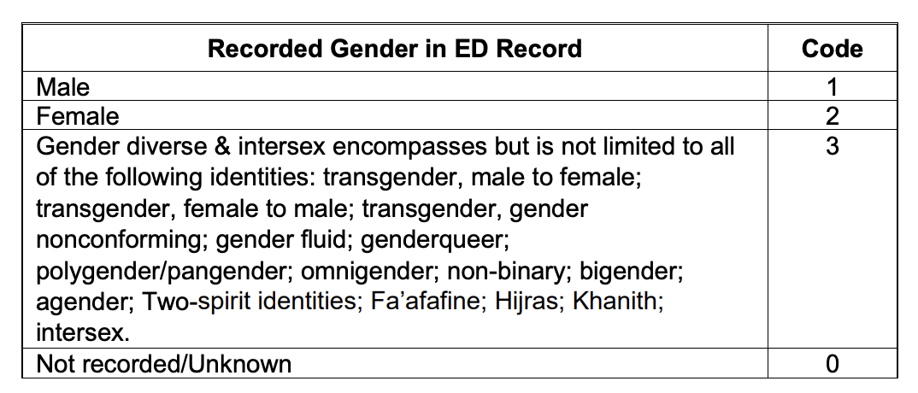
      - Race/Other Race
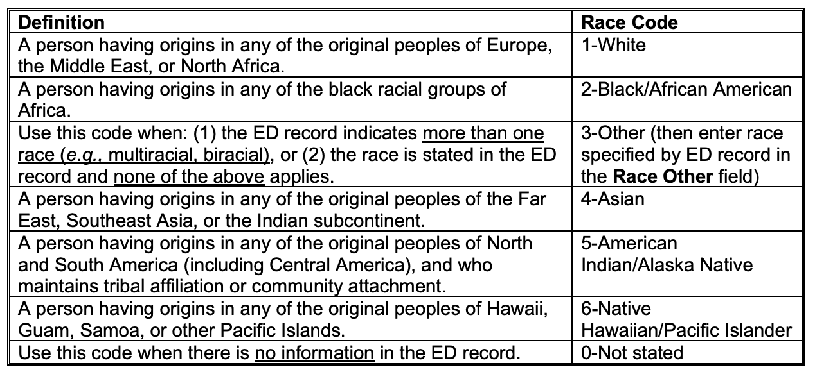
      - Hispanic
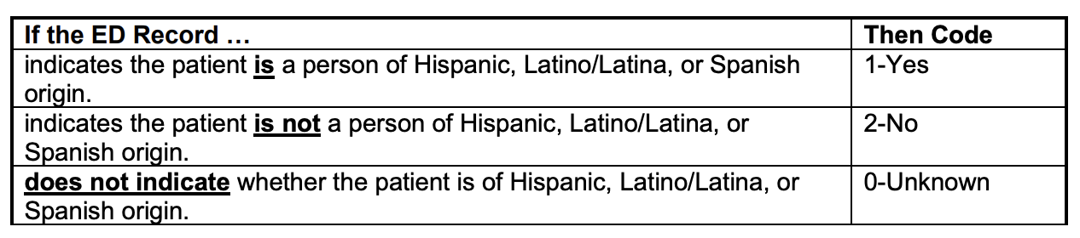

      - Body Part/Body Part 2
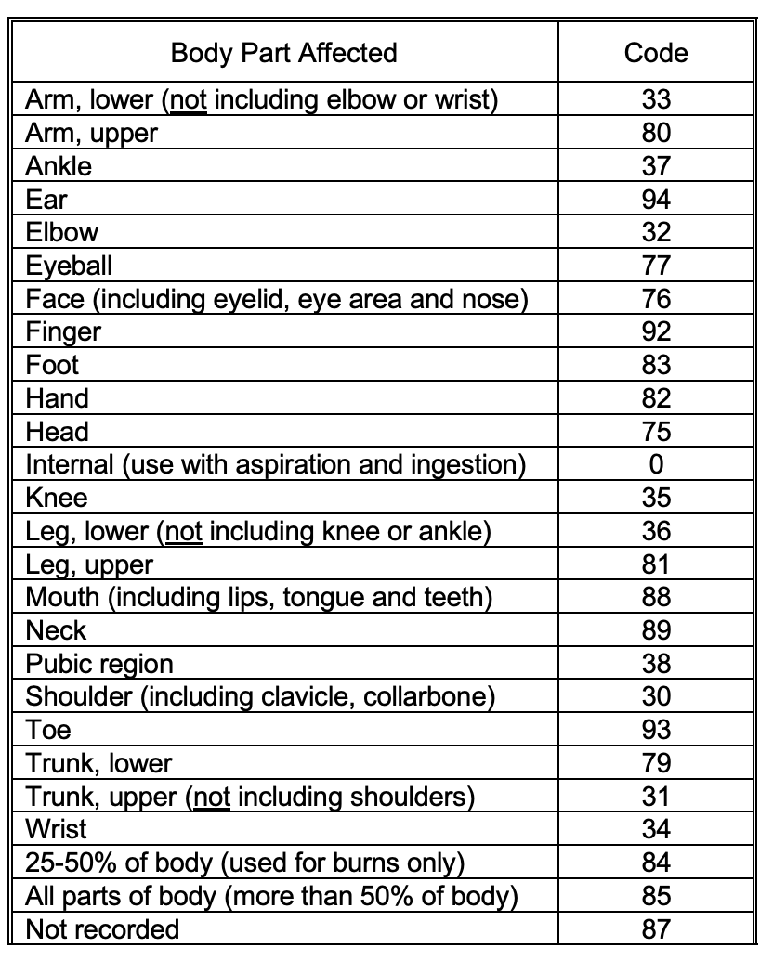
      - Diagnosis/Diagnosis 2
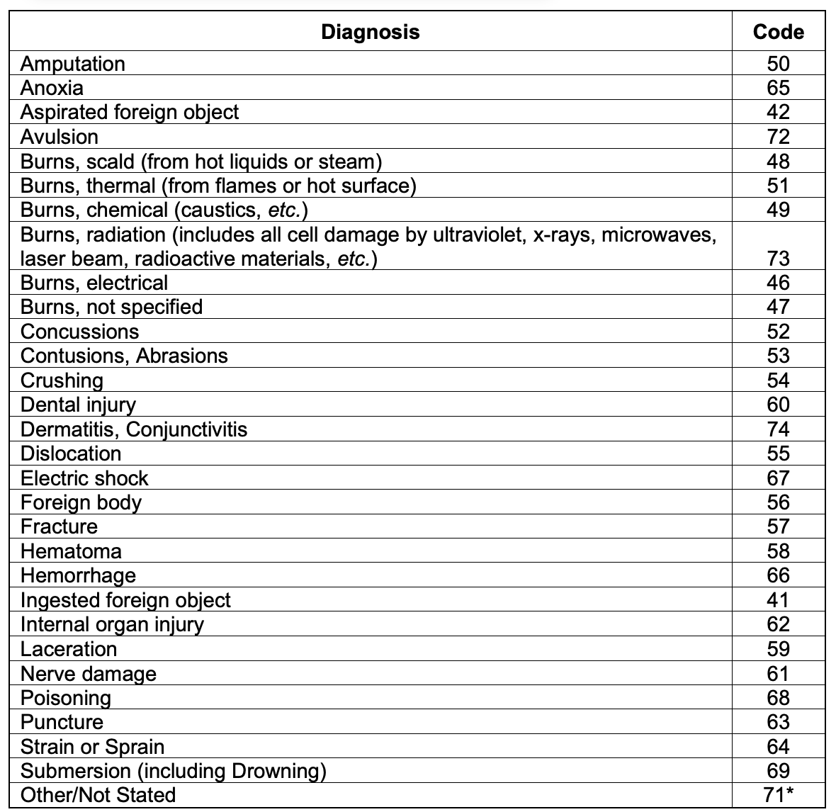
      - Disposition
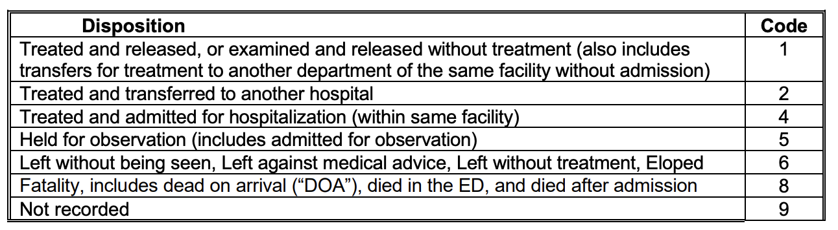
      - Location
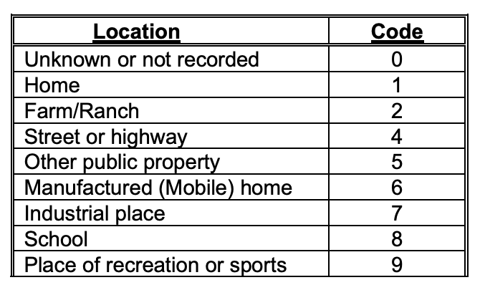
      - Fire Involvement
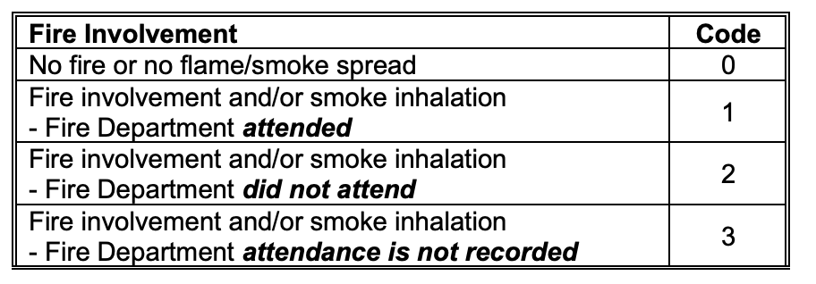
      - Product 1/Product 2/Product 3
Refer the appendix section of the NEISS Coding manual.
https://www.cpsc.gov/cgibin/NEISSQuery/Data/Info%20Docs/2023%20NEISS%20Coding%20Manual.pdf

2.3 Data Exploration Report

2.3.1 Univariate Analysis
Top 30 Injury count by Age group 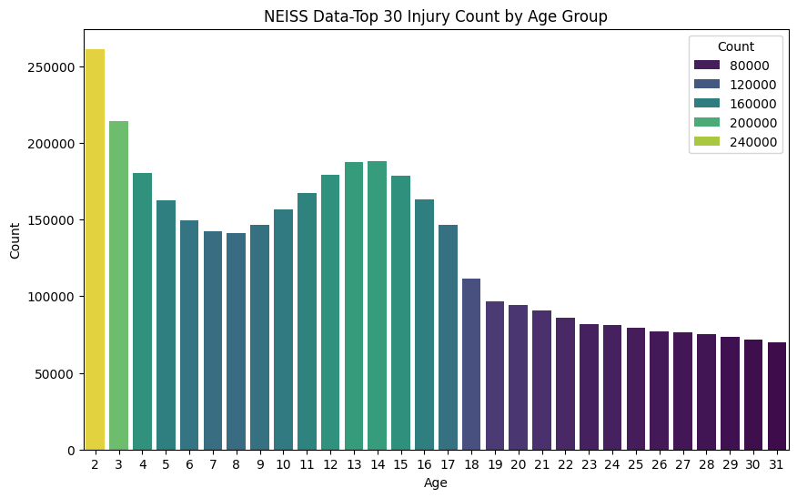
From the chart, we can see that the injury count is high among children and then after the age of 18, stabilizes. The number of injuries seems to peak for children of age 1-2 years.

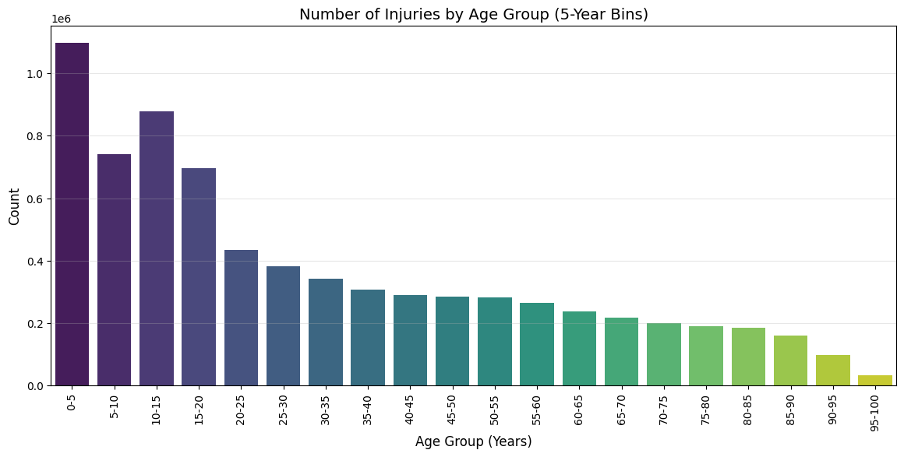

The number of injuries reduces after the age of 75 years.

Injury Count by Sex

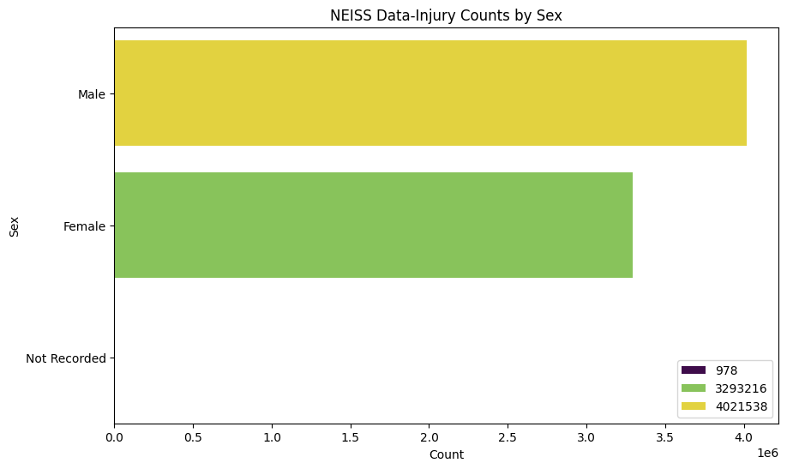

The injury due to the use of consumer products is more among males.

Injury Count by Race

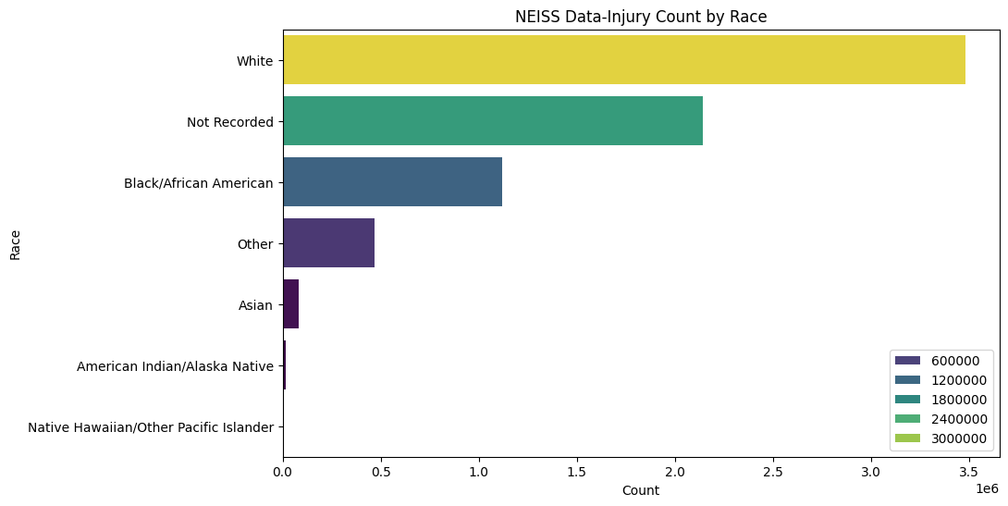
Whites accounted to the most of the injuries’ reported into the ER department.

Injury Count by Other Race

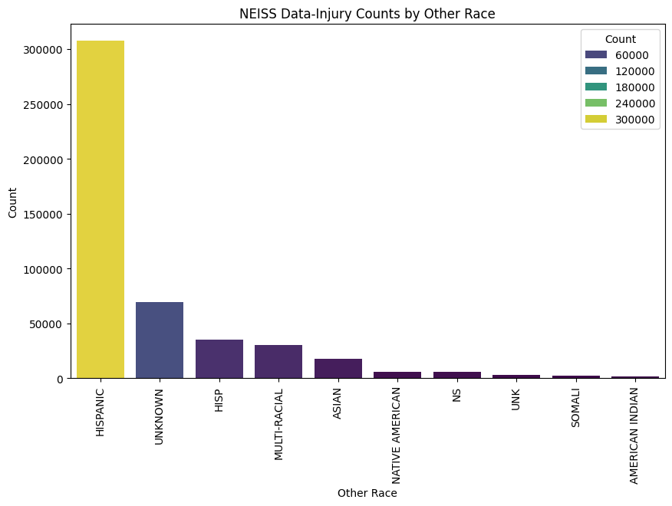

Hispanics accounted for the highest number of injuries reported.

Injury by Body Part

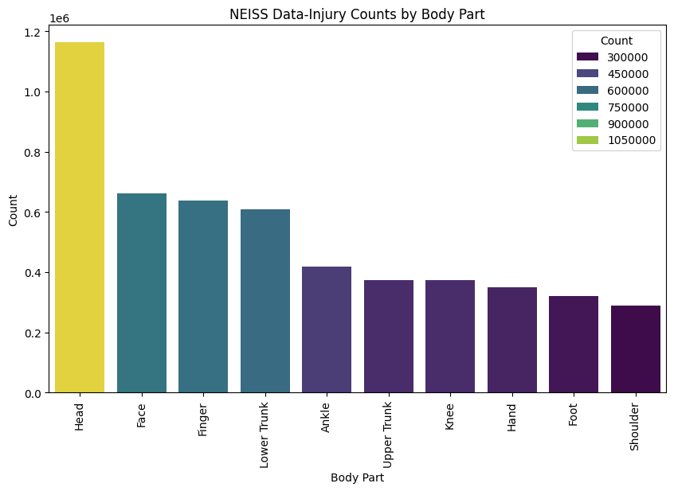

Head followed by Face, Finger and Lower Trunk contributed to the highest number of injuries.

Injury by Body Part 2

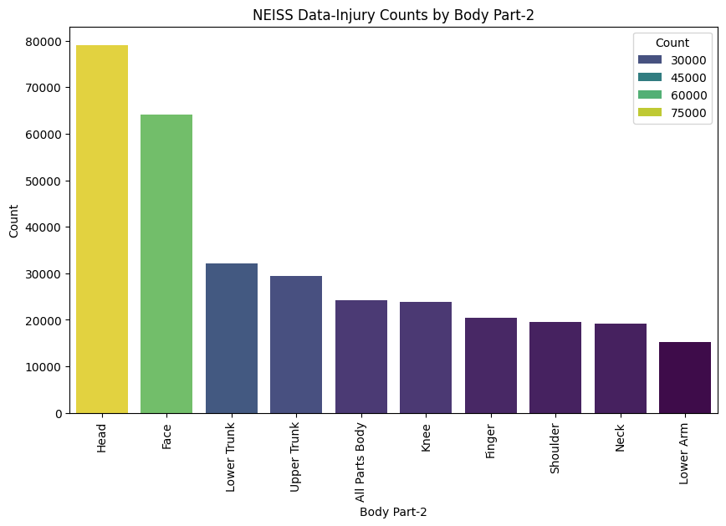

Head followed by Face and Lower/Upper Trunk contributed to the highest number of injuries.

Injury count by diagnosis

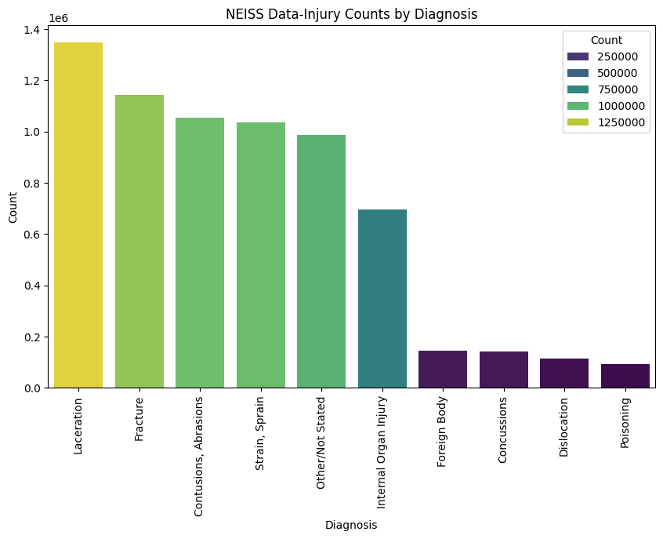

Laceration followed by Fracture, Abrasions and Strain/Sprain contributed to the highest number of injuries.

Injury Count by Diagnosis 2

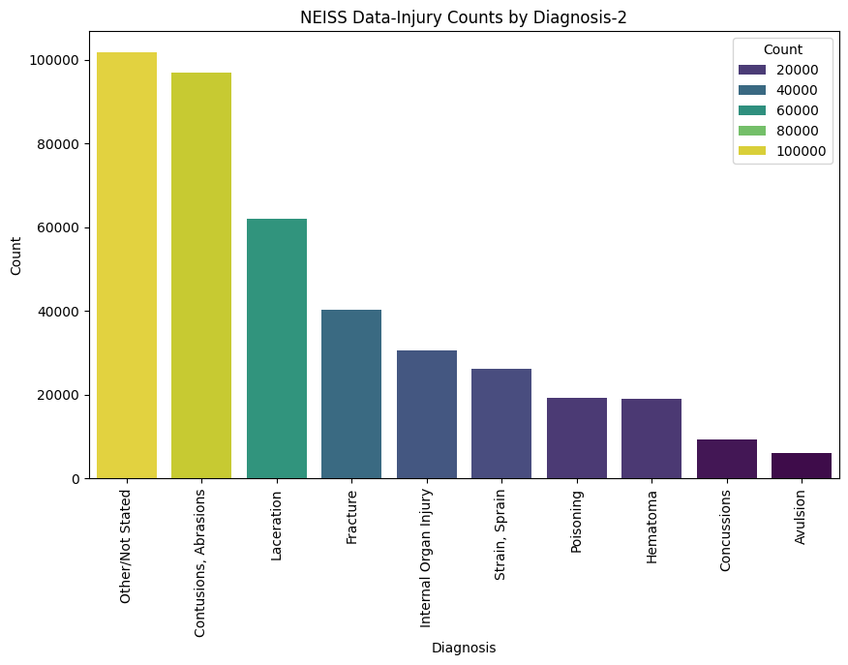

Abrasions followed by Lacerations and Fracture contributed to the highest number of injuries. We also see a huge number of observations without a Diagnosis 2. This could be from pre 2019 data or could be because of the absence of secondary diagnosis.
Injury Count by Disposition

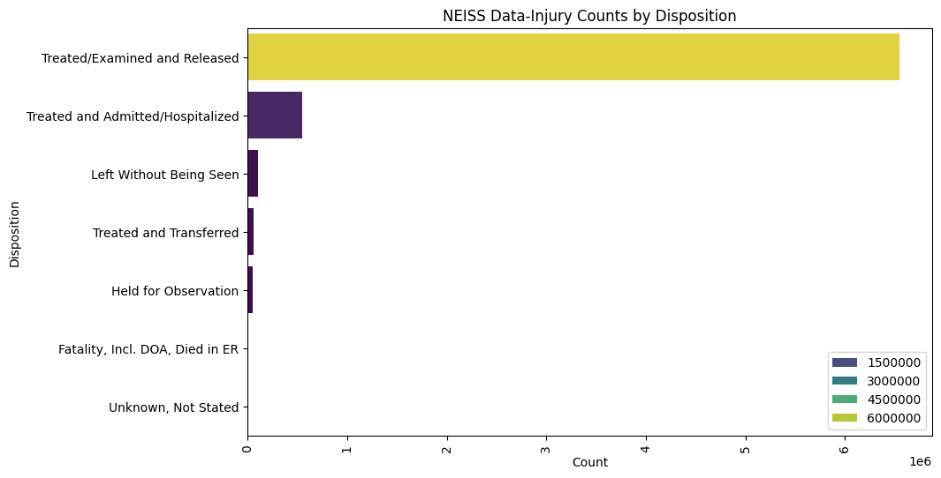

Most of the patients who went to the ER were Treated and Released. The NEISS data seems to be unbalanced, and we may need to use techniques to over sample the minority class. 90% of all the Injuries were treated/examined and released. 7.5% of the Injuries were Admitted/Hospitalized.
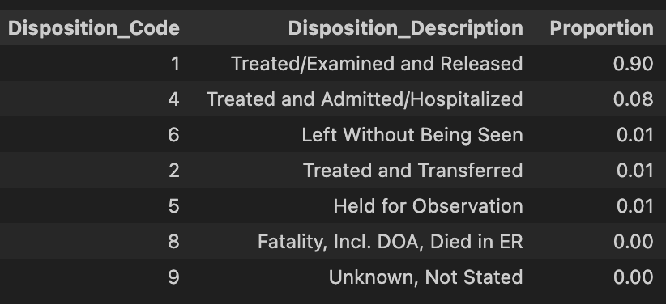

Based on the disposition, we need to create a new feature 'Hospitalized' that groups the below dispositions.

Disposition Code | Hospitalized (Yes/No)
4,2,5,8 | Yes
1,6,9 | No

Injury Count by Location of Injury

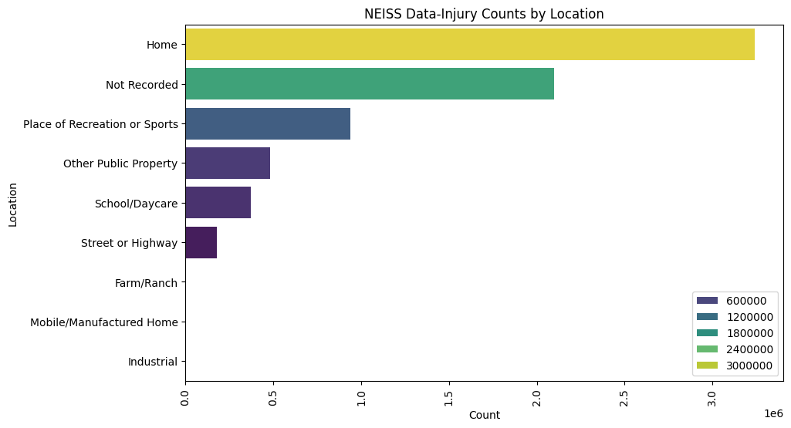

Most of the injuries happened at home followed by not recorded/unknown, sports, or at public property.

Injury by Product

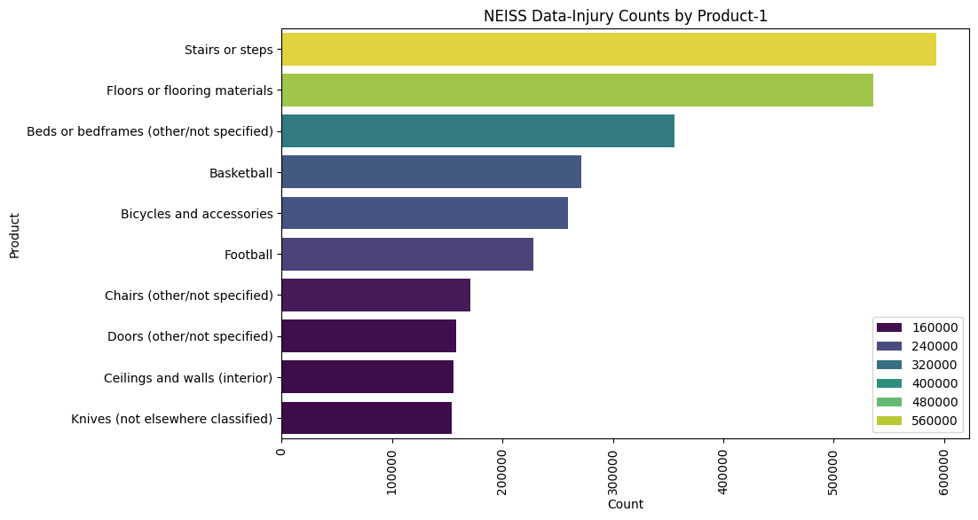

Stairs/Steps followed by Floors and Beds seems to be causing the highest injuries. Recreational activities/Sports seems to be also causing lot of injuries.

Injury by Narrative

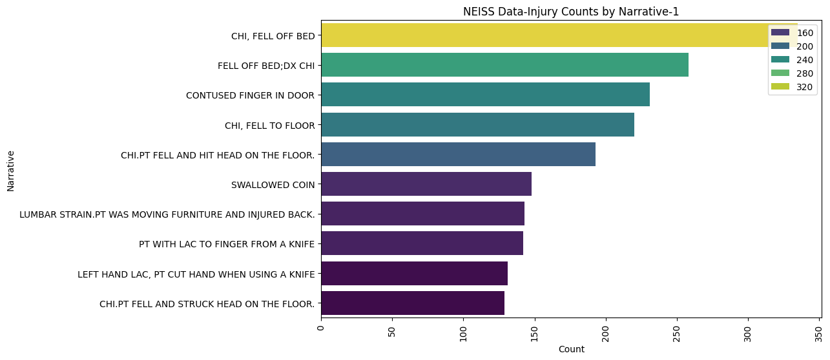

Most of the injury seems to have happened by Falling of the bed or by contusion of finger in door.

Word Cloud of Narrative

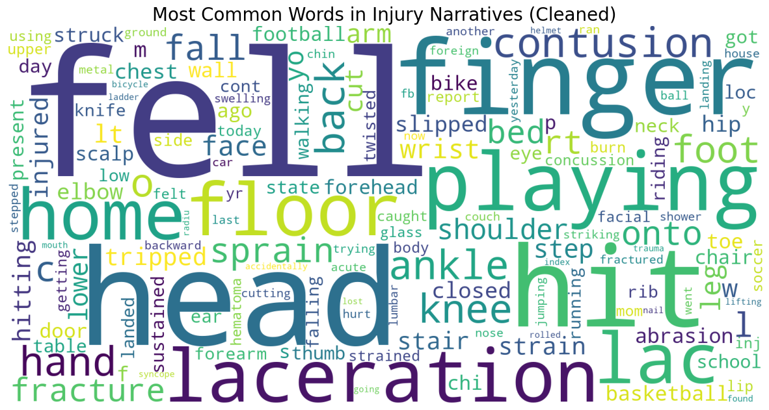

The word cloud from the narrative highlights falls, head, laceration, finger, injury during play as most prominent words.

2.3.2 Bivariate Relationships
Product Categories Vs Age Group

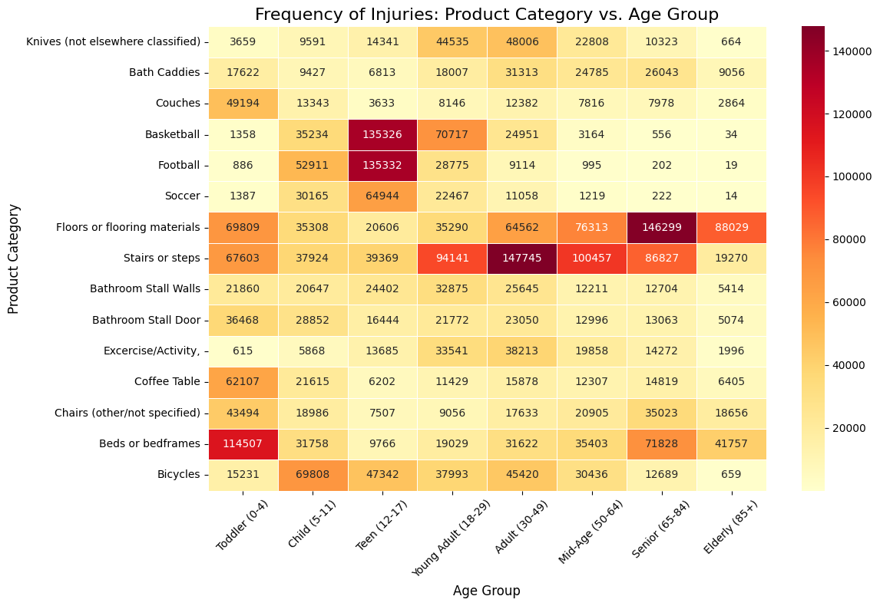

The above charts list the product categories that is dangerous across age groups.

Product Categories Vs Diagnosis
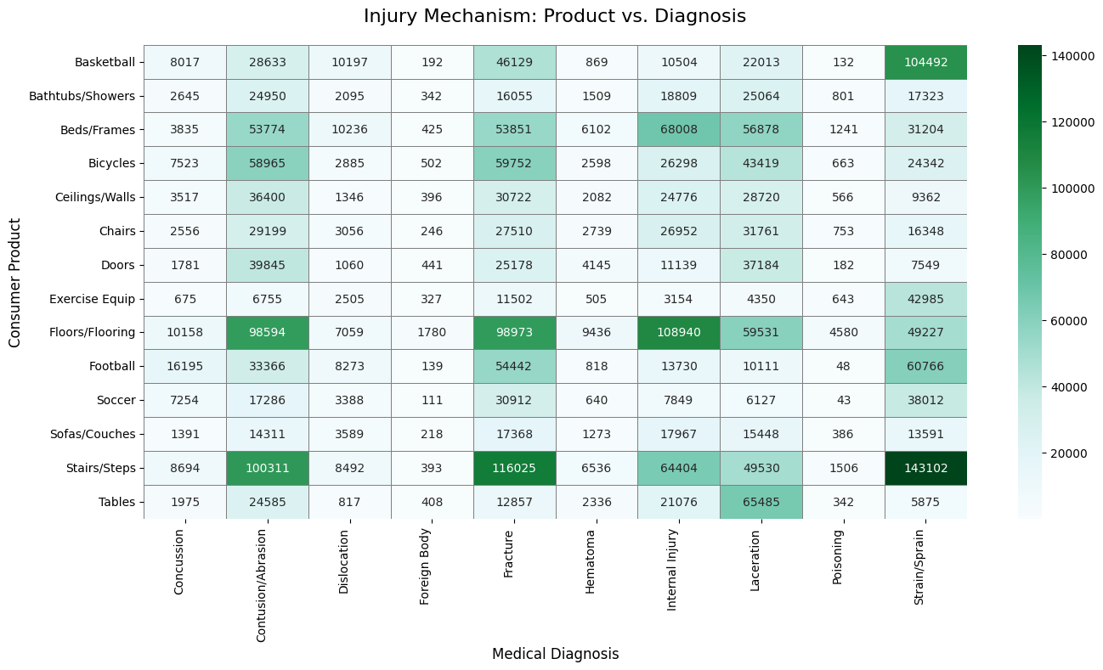

The above charts list the product categories and the corresponding injuries caused by the usage.

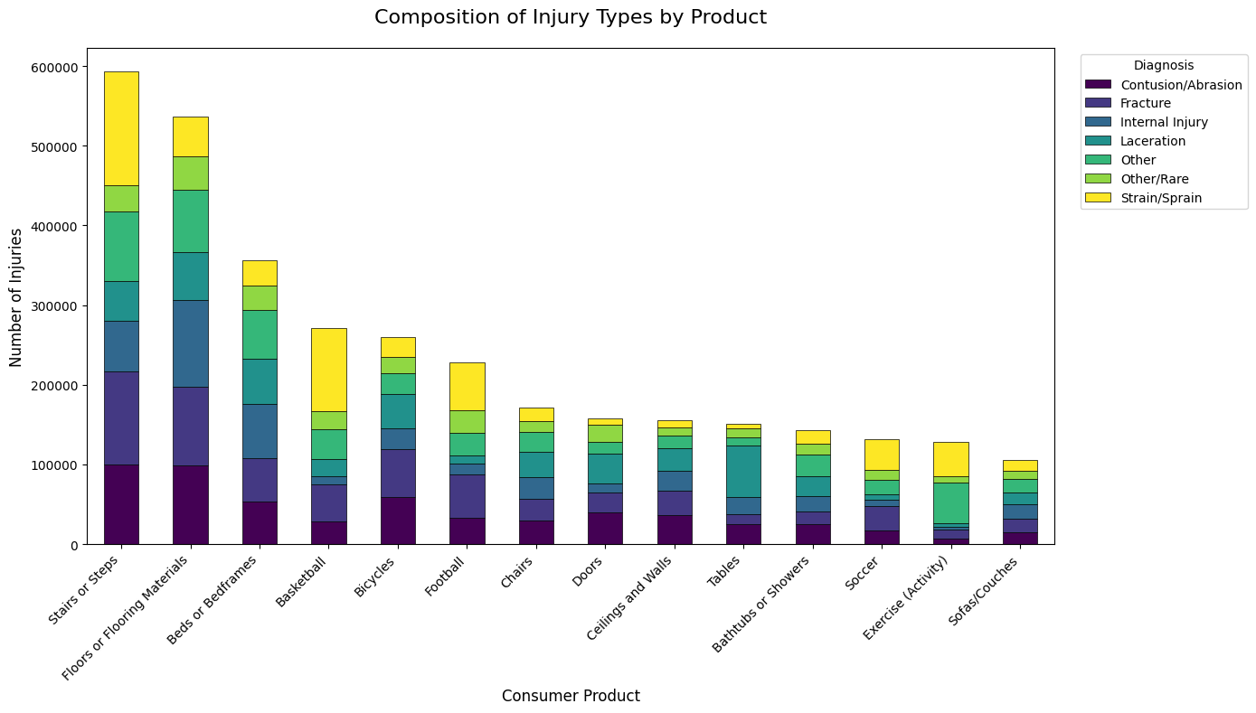

Disposition Vs Product

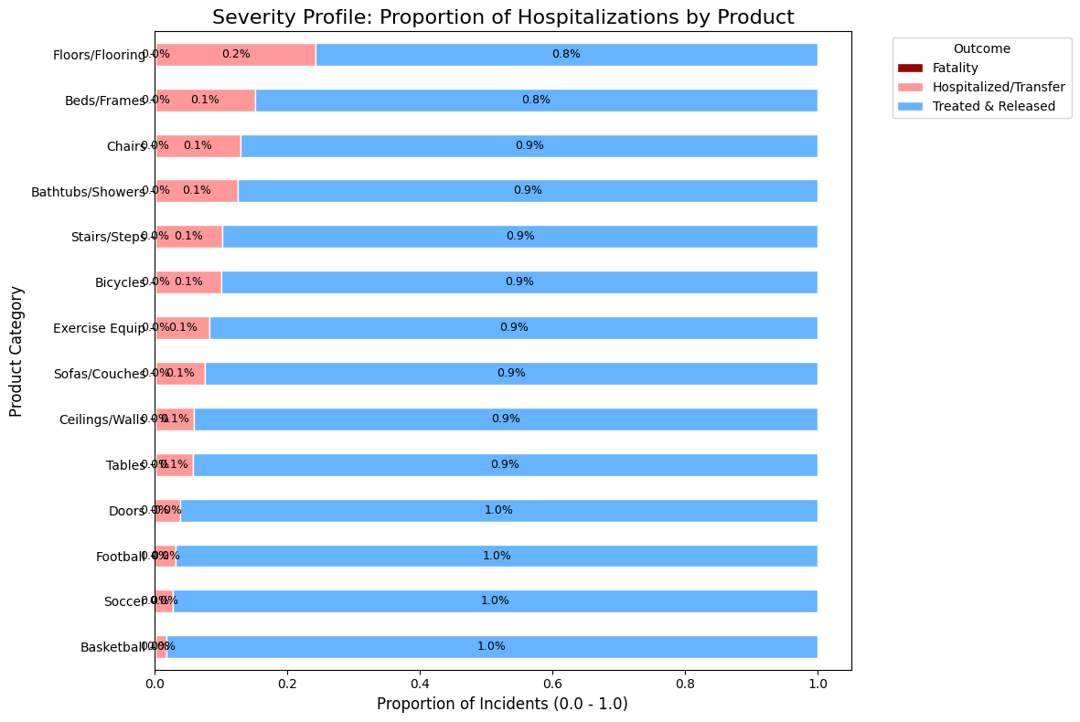

Sex Vs Product

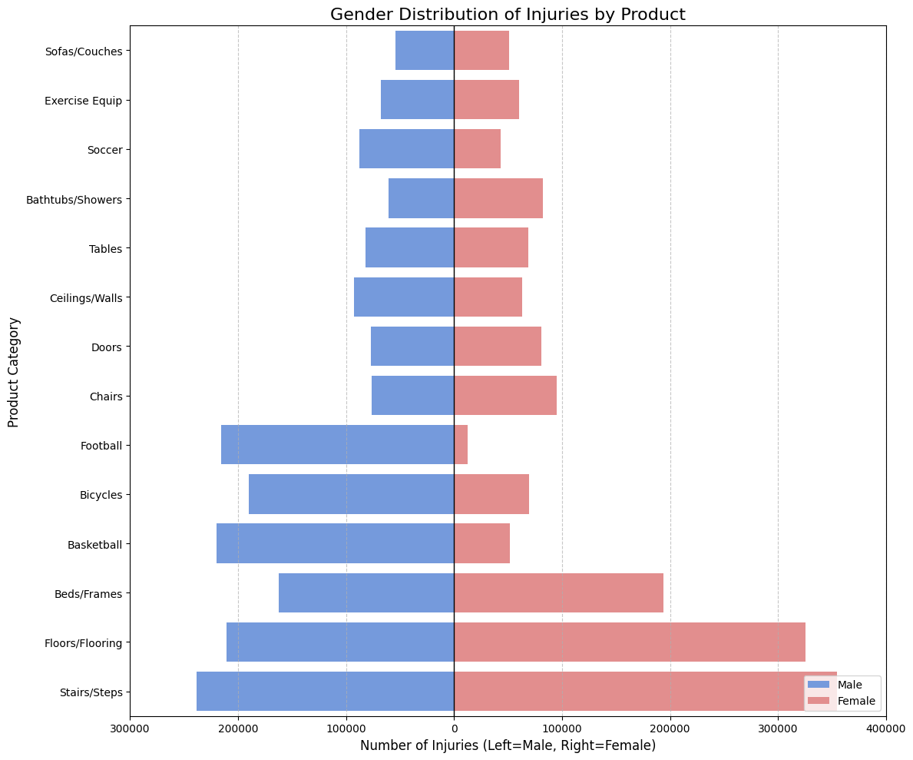

2.3.3 Temporal Patterns and Trends
Injury Count over year
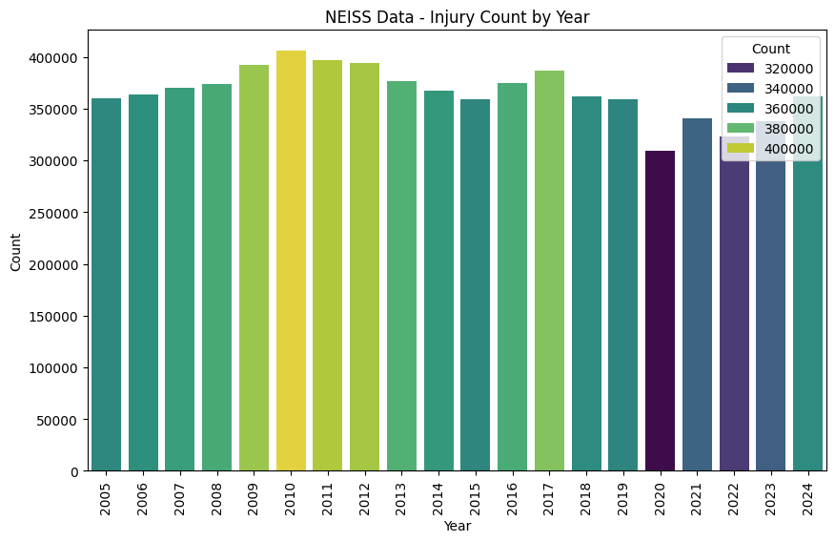

Injury Trend over years

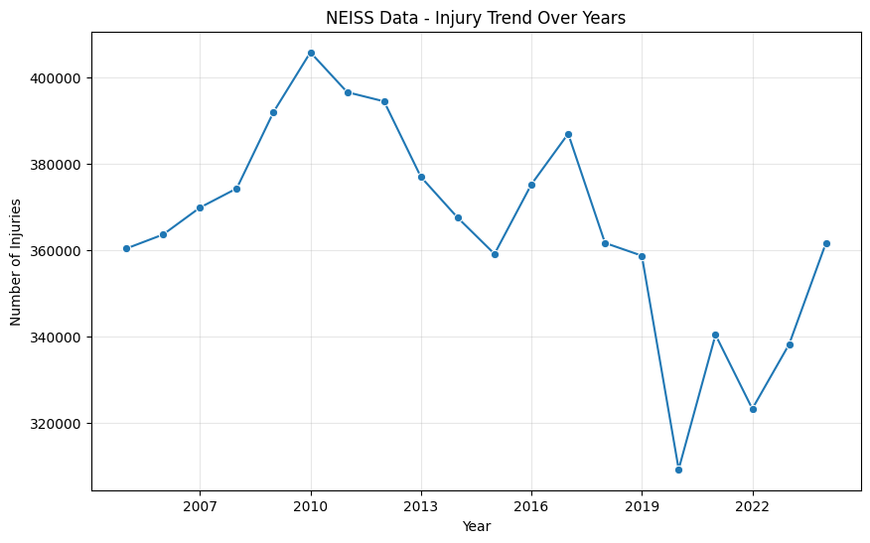

Count of Injury Data by Month

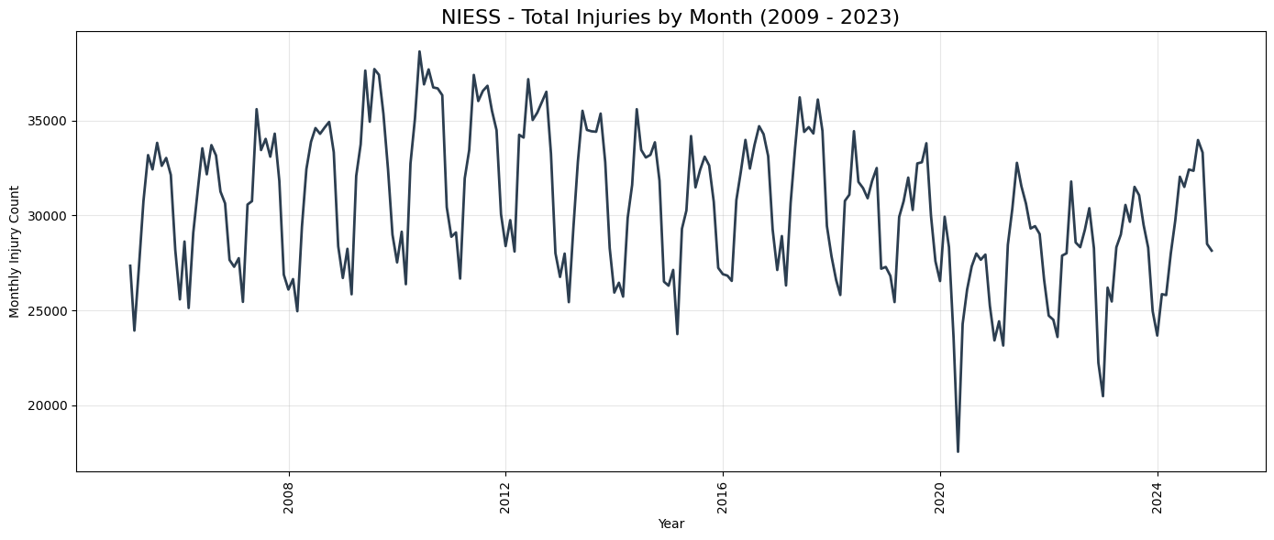

Seasonal Component - We see a seasonal component in the data for every year. The number of injuries peaks during the summer months and reduces in fall and spring. This could be possibly due to the reduction in mobility and social activities during these months. The only exception to this is seen in the year 2019-2020 where the overall injury itself has reduced due to an external factor - the COVID 2019 factor. After the pandemic, the rate of injuries has slowly picked up and follows the seasonal trend like before. This shows the impact of external factors/shocks like the pandemic or mobility/economic (fewer people involved in recreational, work or public activities) reasons causing this decrement. The seasonal factor is robust and is predictable.
The data exhibits a seasonal cyclicality and declining trend between 2005 to 2011 shows an upward trend in the injury counts where in 2011 it tapers off at 400K. The injury counts show a slight decline between 2012 -2019 - this could be again due to an external factor like population or increase in the safety awareness contributing to the slight decline.

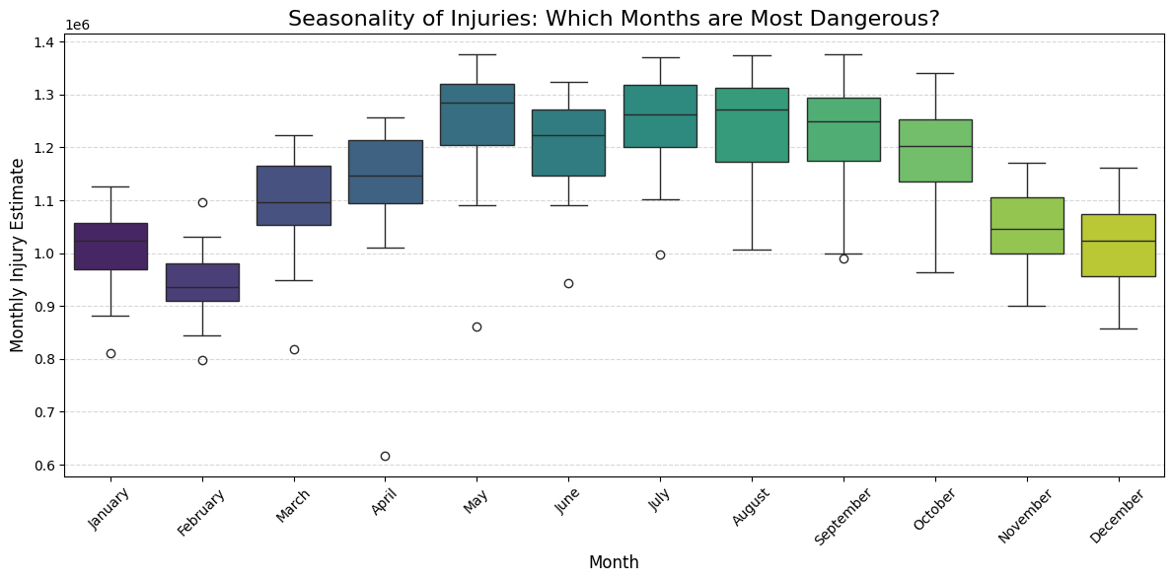

The data points to three critical insights:

1. Injury rates are heavily dependent on population mobility and economic activity
2. Seasonal factors remain robust and predictable, and
3. Exogenous shocks (pandemic, policy changes) can produce sustained structural shifts in injury epidemiology. For public health planning and emergency preparedness, the pre-2020 baseline may no longer reflect current injury risk, and forward projections should account for the new post-pandemic normal.
4. Summary months have the most injuries, and we see a fall in the injuries in the spring and fall.

2.3.4 Organizational Level Segmentation

Injury by Hospital Stratum

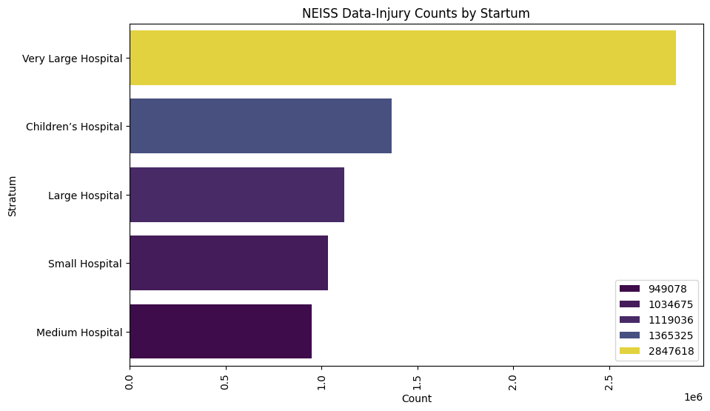

A lot of injuries seem to have happened in large hospitals.

2.4 Data Quality Assessment

2.4.1 Completeness Analysis
Missing/Truncated Data Quantification and Analysis
Summary of features with NULL or Missing Data with percentage data missing and NULL

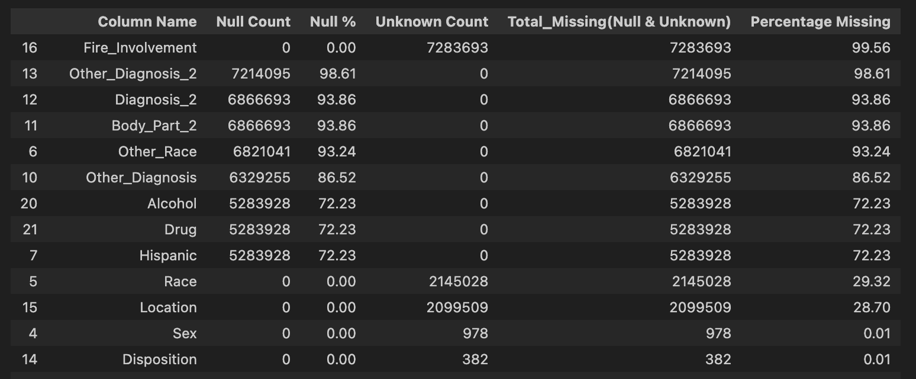

Fire Involvement: A fire Involvement with a value of 0 could mean that either no fire was involved or fire involvement not recorded. 99.56% of the observations are missing this information. We can scan the narrative attribute to see if can identify a Fire involvement – if not, we might need to ignore this attribute.

Other Diagnosis_2: This feature was added for data beyond 2019.This could be one reason why the feature has many unknown values. This is the field to store additional diagnosis if needed. 98.61% of the data is missing this information. We might need to ignore this feature.

Diagnosis_2: This feature was added for data beyond 2019.This could be one reason why the feature has many unknown values. This is the field to store additional diagnosis if needed. 93.86% of the data is missing this feature. We might need to ignore this feature.

Body Part_2: This feature was added for data beyond 2019.This could be one reason why the feature has many unknown values. This is the field to store additional information of the body part that was injured. 93.86% of the data is missing this information and we might need to ignore this feature.

Other Race: This attribute is only used we have a “3- Other” entered in the race attribute. We need to use this as a separate category. 93.24% of the data is missing this information.

Other Diagnosis: This feature is only used we have a “71 – Other/Not Stated” entered in the diagnosis attribute. 86.52% of the data is missing this information.

Alcohol: This feature was added for data beyond 2019.This could be one reason why the feature has many unknown values. We need to use this attribute in combination with the Narrative feature to check if there is a true alcohol usage involved when the injury occurred.

Drug: This feature was added for data beyond 2019.This could be one reason why the feature has many unknown values. We need to use this attribute in combination with the Narrative feature to check if there is a true Drug usage involved when the injury occurred.

Hispanic: This feature was added for data beyond 2019.This could be one reason why the feature has many unknown values. We need to use this attribute in combination with the Narrative feature to check if there is a true Drug usage involved when the injury occurred.

Sex: 978 records are missing this information and contributes to the 0.01% of the overall data. We can update the majority class information for this missing data, and this will not impact the modelling.

Race: 29% of the records does not have a race or has a 0-not/stated in ED record. We will treat this as a separate category during modelling.

Disposition: 382 records have a disposition value ‘9 – Unknown/Not Stated’. During the feature engineering phase, we may need to consider this as a category that does not cause Hospitalization.

Field Truncation: The data in many of the narrative field is truncated and is un-usable.

Completeness Trend Overtime

The NEISS data from January 2005 to December 2024 is complete and the dataset has observation for each day.
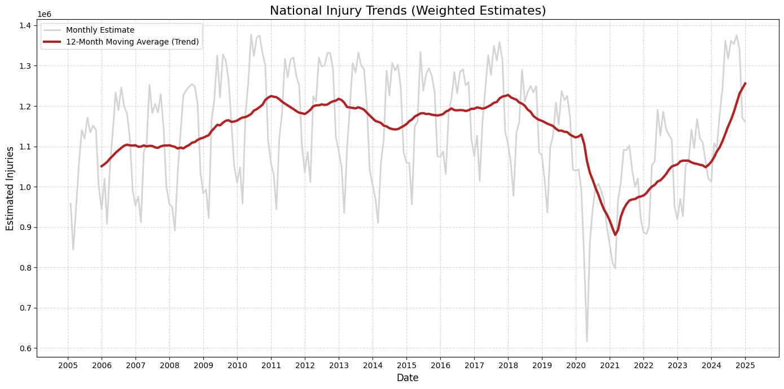

2.4.2 Accuracy Assessment
None of the data from the year January of 2005 – December 2024 is duplicated and each record corresponds to a unique ER admission

The data in NEISS dataset is from the medical records that are entered into the system at high stress condition and hence prone to errors (like hospitals misclassifying the products)

The data sampling is taken from approximately 100 hospitals and is weighted to represent the entire population in the USA. This could possibility induce selection bias as NEISS only incudes injuries reported at the ER departments and ignores, the ones that are self-treated, treated by the primary care physicians or at the urgent care. We need to use weight in conjugation to the stratum to generate statistically valid national estimates.

Range Validation of Numerical Fields:
Age:
The age falls in plausible range from 0.8 – 113 Years.
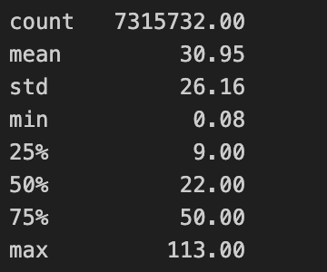
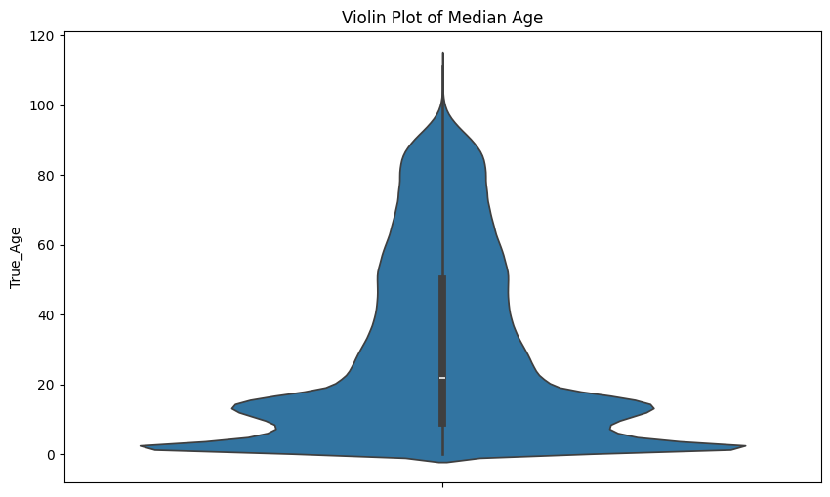

Most of the data is of patients between 0.8-40 years of age.

Outlier Detection for Age:
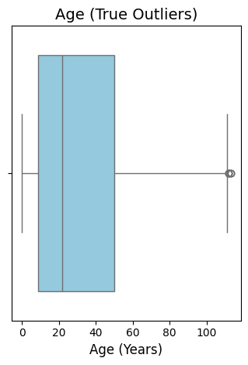

Treatment Date:
The range of treatment date is from 01/01/2005 to 31/12/2024 and does not fall outside of this range.

2.4.3 Consistency Evaluation
Standardization Issues:
Age Attribute:
NEISS uses unique code to represent ages < 2 years, and we need to make sure that we convert age to a common scale of years. After the conversion, if there are any records with an age of zero, we can either drop them if the volume is low or we can use the median age to substitute the data.

Temporal Consistency:
NEISS product codes are susceptible to change and NEISS could add, delete or merge codes annually and this could create inconsistencies in the product codes. The below list of products 47 products shows inconsistent reporting and does not show up in some years.
Product Codes that are inconsistent:
394, 556, 569, 574, 876, 897, 899, 1132, 1145, 1317, 1329, 1381, 1394, 1395, 1417, 1465, 1466, 1527, 1543, 1545, 1552, 1606, 1618, 1620, 1629, 1706, 1707, 1710, 1841, 1855, 1909, 3215, 4802, 5004, 5016, 5017, 5019, 5020, 5021, 5022, 5023, 5024, 5025, 5042, 5043, 5045, 5046
Contingency: We could remove records from the dataset with these products.

Sampling Consistency:
The number of participating hospitals in NEISS program could vary every year. The weight variable adjusts the for this variation. We should always use the weight variable when comparing the data across years and using raw count to compare the data across years is statistically invalid.

2.4.4 Timelines and Currency
Data Freshness:
The data is entered into the NEISS system daily by the NEISS hospital coordinator. The finalized data for the prior year is made available by April of the next year. The data is available to perform seasonal and trend analysis. We will be able to perform the analysis of Finalized data till the prior year at any point of time.

Data Updates:
When we query the NEISS database online, we can obtain current year live data, but this data is susceptible to updates. Once the financial year ends, the data is then released for public consumption after cleaning and review, and this data is the finalized data. The transient state updates are made daily by the NEISS coordinator and will be reflecting in the NEISS portal. The fields like Disposition, Product code, Diagnosis are updated by the NEISS coordinator daily into the portal. We should not use transient data from the current financial year for analysis and should only use finalized data to reduce the data reproducibility drift.

Temporal Gaps:
NEISS data from January 2005 – December 20024 does not have any gaps and is a good currency for current analysis and can be used for analyzing the trend and seasonality. The data present the NEISS database is updated daily and allows for seasonal analysis.

Historical Depth:
NEISS data is available online for the last 20 years and we will be able to use the data for historical analysis.

2.4.5 Relevance and Coverage

NEISS is the primary dataset used by the US Consumer Product Safety Commission (CPSC) to issue recalls. Using this data hence simulates the workflow used by the safety regulator. This dataset also connects the product to the consequence/diagnosis and is the right data that could help us pinpoint design deficiencies and consumer impact. However, NEISS records only product involvement and not the causality of injury. We need to understand if the product caused an injury by scanning the narrative data but in many cases could be incomplete.

Population Coverage:
Data collected by NEISS could possibility induce selection bias as NEISS only includes injuries reported at the ER departments and ignores, the ones that are self-treated, treated by the primary care physicians or at the urgent care.

Scenario Representation:
NEISS covers only consumer products and doesn’t cover the injures caused by products managed by other agencies like Automobiles/Drugs/Medicine/Violence/Work Related Injuries.

Geographic Scope:
The data sampling is taken from approximately 100 hospitals and is weighted to represent the entire population in the USA. This could induce a bias that could miss including local injuries/patterns occurring in areas not represented by these selected hospitals.

2.4.6 Data Quality and Impact Assessment
1. Data Completeness
Around 30% of the collected data is missing Race (Unknown/Not Recorded) information. This could mean that we will not be able to reliably analyze if a product specifically injures a specific ethnic group. We may instead use the Age and Sex for demographic analysis and not use Race.

The narrative field of many of the records are truncated and we might not be able to identify the root cause of the injury.

- Data Accuracy
NEISS relies on data entered by hospital staff in high stress environments and hence prone to errors. The selection bias systematically underestimates minor injuries (that needs hospitalization) and fatalities.
- Data Consistency
Product definitions change over time as CPSC could add, delete, merge products every year. The hospitals involved in the NEISS data also change and hence counting the raw cases year to year is incorrect and we need to use weighted estimates.
- Validity
NEISS records only product involvement and not the causality of injury. We need to understand if the product caused an injury by scanning the narrative data but in many cases could be incomplete.

